Eyes on 2022
December 3-5, 2021
Virtual Event

Target Audience
This event is intended for ophthalmologists and optometrists.

Learning Objectives
Upon completion of this conference, participants should be able to:

- Establish best practices in glaucoma and dry eye disease management, establishing multifactorial ocular disease management in daily practice
- Define and implement new, evidence-based treatments and technologies for dry eye disease and refractive surgery
- Appraise the quality of co-management between disciplines in surgical retina, to ensure good patient outcomes following vitrectomy and microscopic surgery
- Integrate novel research as it pertains to diagnostics and treatments of retinal diseases with current best practices to continually improve quality of patient care and patient outcomes, including the latest research on anti-VEGF treatments and alternatives

Method of Participation
Statements of credit will be awarded based on the participant's attendance. A statement of credit will be available upon completion of an online evaluation/claim credit form available at:

Please claim your credit by December 31, 2021.
If you have questions about this CE activity, please contact AKH Inc at joldman@akhcme.com.

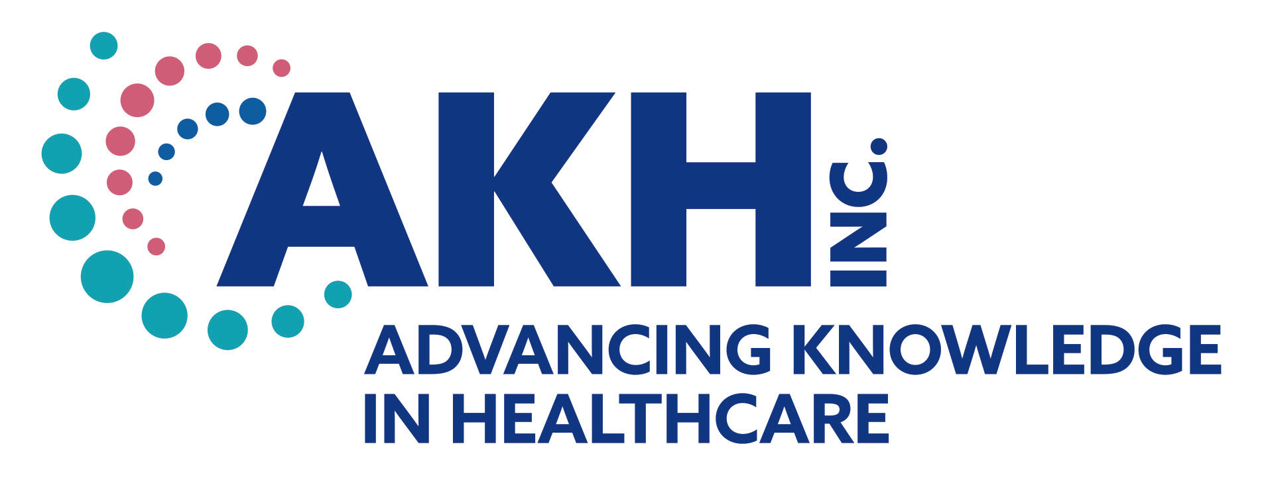
CE credit provided by AKH Inc., Advancing Knowledge in Healthcare. This activity is jointly-provided by AKH Inc., Advancing Knowledge in Healthcare and iVista Medical Education, Inc.

In support of improving patient care, this activity has been planned and implemented by AKH Inc., Advancing Knowledge in Healthcare and iVista Medical Education, Inc. AKH Inc., Advancing Knowledge in Healthcare is jointly accredited by the Accreditation Council for Continuing Medical Education (ACCME), the Accreditation Council for Pharmacy Education (ACPE), and the American Nurses Credentialing Center (ANCC), to provide continuing education for the healthcare team.

Physicians
AKH Inc., Advancing Knowledge in Healthcare designates this live activity for a maximum of 7.0 AMA PRA Category 1 Credit(s)™.

Commercial Support
This activity is supported from an independent medical education grant from Alcon, Johnson & Johnson, Sight Sciences, Sun Pharma, and Visus Therapeutic, Inc.

Disclosures
It is the policy of AKH Inc. to ensure independence, balance, objectivity, scientific rigor, and integrity in all of its continuing education activities. The planners and faculty must disclose to the participants any significant relationships with ineligible companies whose primary business is producing, marketing, selling, re-selling, or distributing healthcare products used by or on patients.” or with the commercial supporter of this accredited continuing education activity. Identified conflicts of interest are mitigated by AKH prior to the planners/faculty assuming their role in this accredited continuing education activity.

DISCLOSURES
Name | Relationship | Commercial Interest
Christopher R. Adam, MD (faculty) | N/A | Nothing to disclose
Michael J. Ammar, MD (faculty) | N/A | Nothing to disclose
Ashley Brissette, MD, MSc, FRCSC (faculty) | N/A | Nothing to disclose
Eric Chin, MD (faculty) | Researcher | Allergan; Chendgu Kanghong Biotechnology; Citrus Therapeutics; Genentech; IVERIC Bio; Kodiak Sciences; Opthea; Novartis
Constance Okeke, MD, MSCE (faculty) | Consultant | Aerie; Akorn; Alcon; ALLERGAN; B+L; Eyenovia; Nova Eye; Glaukos; Ivantis; Mediprint; MST; Novartis; Reichert; Santen; Sight Sciences; Sun Pharmaceuticals; Thea; Visionology; Visus Therapeutics
 | Contracted Research | B+L; Glaukos; Nicox; Nova Eye
 | Royalty | Kugler Publications
 | Speakers Bureau | Aerie; Akorn; Alcon; ALLERGAN; B+L; Nova Eye; Glaukos; MST; Sight Sciences; Sun Pharmaceuticals
Nimesh A. Patel, MD (faculty) | N/A | Nothing to disclose
Bradley Sacher, MD (faculty) | N/A | Nothing to disclose
Dorothy Caputo, MA, BSN, RN, CE Director of Accreditations/Lead Nurse Planner | N/A | Nothing to disclose
AKH Inc. Staff and Planners | N/A | Nothing to disclose
iVista Staff and Planners | N/A | Nothing to disclose
All of the relevant financial relationships listed for these individuals have been mitigated.

Disclosure of Unlabeled Use and Investigational Product
This educational activity may include discussion of uses of agents that are investigational and/or unapproved by the FDA. Please refer to the official prescribing information for each product for discussion of approved indications, contraindications, and warnings.

Disclaimer
This course is designed solely to provide the healthcare professional with information to assist in his/her practice and professional development and is not to be considered a diagnostic tool to replace professional advice or treatment. The course serves as a general guide to the healthcare professional, and therefore, cannot be considered as giving legal, nursing, medical, or other professional advice in specific cases. AKH Inc. specifically disclaims responsibility for any adverse consequences resulting directly or indirectly from information in the course, for undetected error, or through participant's misunderstanding of the content.

